Assignment 4.1

Loading the data file in VM

PIG_CLASSPATH=/home/hadoop/HADOOP/hbase-0.98.4-hadoop2/lib/hbase-server-0.98.4-hadoop2:/home/hadoop/HADOOP/hbase-0.98.4-hadoop2/lib/hbase-*.jar;

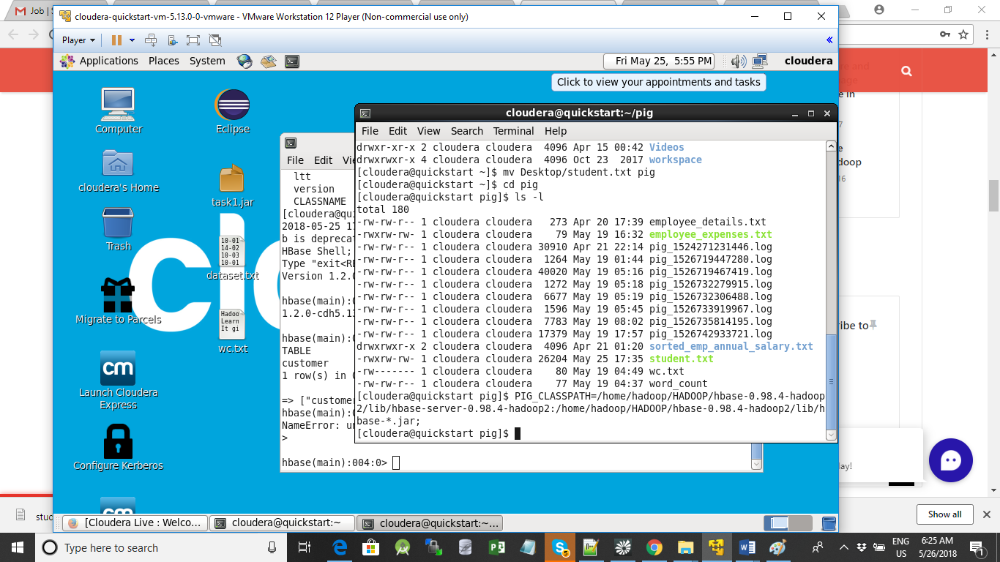

**Creating Hbase Table**

hbase(main):006:0> create 'studentAcad', 'student_data'

0 row(s) in 1.4990 seconds

=> Hbase::Table - studentAcad

hbase(main):007:0> list

TABLE

customer

studentAcad

2 row(s) in 0.0110 seconds

=> ["customer", "studentAcad"]

Putting the file in Hadoop

hadoop fs -put /home/cloudera/pig/student.txt Ajay

Loading the data in PIG

rawD= LOAD Ajay/student.txt using PigStorage (',') AS (StudentName:chararray,sector:chararray,DOB:chararray,qualification:chararray,score:int,state:chararray,randdomName:chararray);

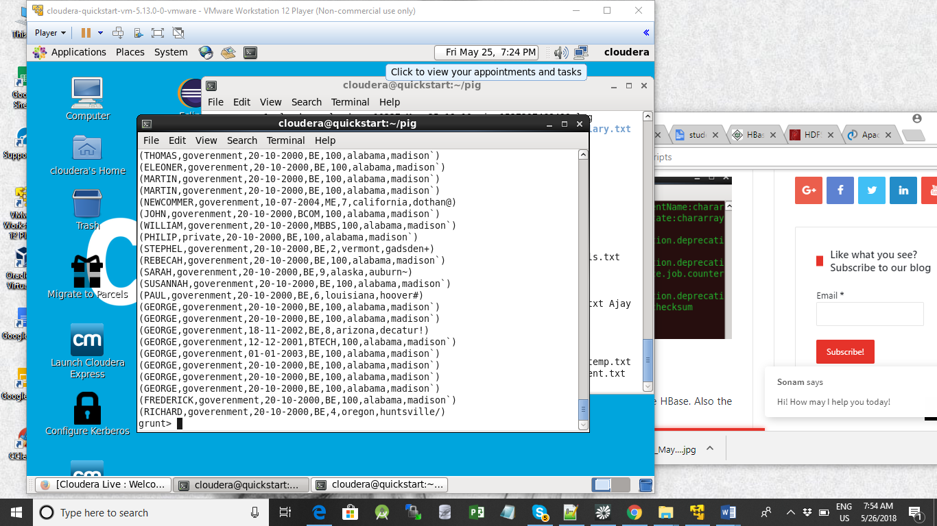

Dump rawD ;

Storing Data in HBASe Table

STORE rawD INTO 'hbase://studentAcad' USING org.apache.pig.backend.hadoop.hbase.HBaseStorage('student_data:StudentName,student_data:sector,student_data:DOB,student_data:qualification,student_data:score,student_data:state,student_data:randomName');

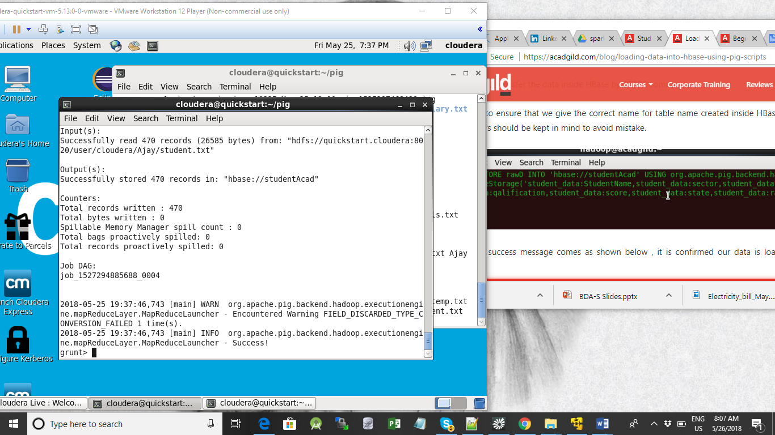

To see the values staored in Hbase table

Scan ‘studentAcad’

